Lithium Market Overview
August 2016

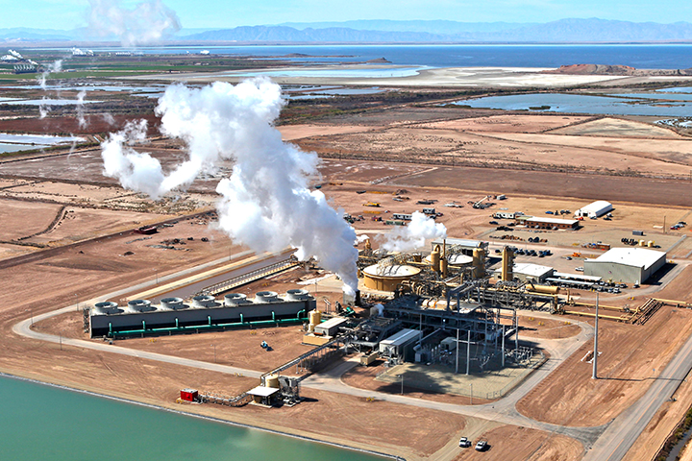

Table of Contents

The Element 3

The Lithium Market 4

Supply 4

Automotive Demand 7

Energy Storage 8

The Future 9

Summary 10

The Element

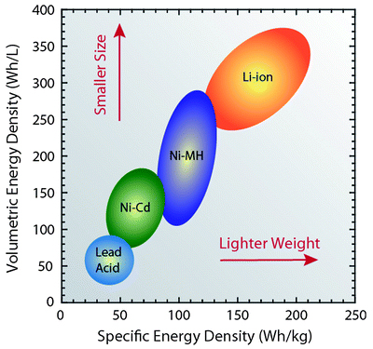
Lithium is a soft silver-white metal that has many applications across several industries and most notably in the rapidly growing battery industry. The property that makes lithium important in this industry is its energy density of 4.32 MJ/L for lithium batteries and 0.9-2.63 MJ/L for lithium-ion batteries. This compares favourably to other accessible electrochemical materials and due to the extreme lightweight nature of lithium (the world’s lightest metal), it is perfect for use in batteries.

Lithium makes up only 0.0007% of the earth's crust and is not found free in nature, it requires extraction. Spodumene, petalite, lepidolite, and amblygonite, the most important minerals containing lithium, are found combined in small amounts of nearly all igneous rocks and in the waters of many mineral springs. In 2015, researchers found a way of using dialysis to extract lithium from seawater however this is not commercially viable from a cost perspective.

Lithium is an element of many uses and was originally used in aircraft engines. Today the biggest uses of lithium are in ceramics (reduces melting point, viscosity and thermal expansion) and batteries. By far the biggest growth market for lithium is in the battery market where demand for portable power, electric vehicles and stationary power are forecast to increase dramatically.
Breaking down the different types of lithium that are extracted from the different processes, you find that lithium carbonate (Li₂CO₃, 18.8% Li) accounts for around 48% of the world’s lithium containing products (25% technical-grade and 23% battery-grade), lithium hydroxide monohydrate (LiOH.H₂O, 16.5% Li) around 16% and the rest in the form of lithium bromide (LiBr, 8.0% Li), lithium chloride (LiCl, 16.3% Li) and lithium minerals.
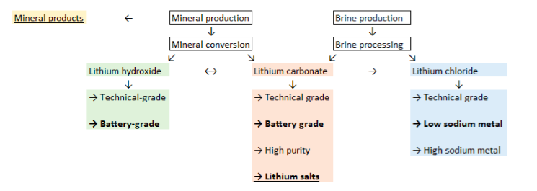

The Lithium Market

With a current total demand of roughly 180,000 to 200,000 tonnes a year, lithium is not priced like other metals such as gold, silver and certain other base metals which are traded on transparent international commodity exchanges. Lithium is instead sold in direct contracts between suppliers and users. In general, the leading oligopoly of 4-6 producers in the sector are controlling the price making full transparency on the market price difficult to track on a daily basis.

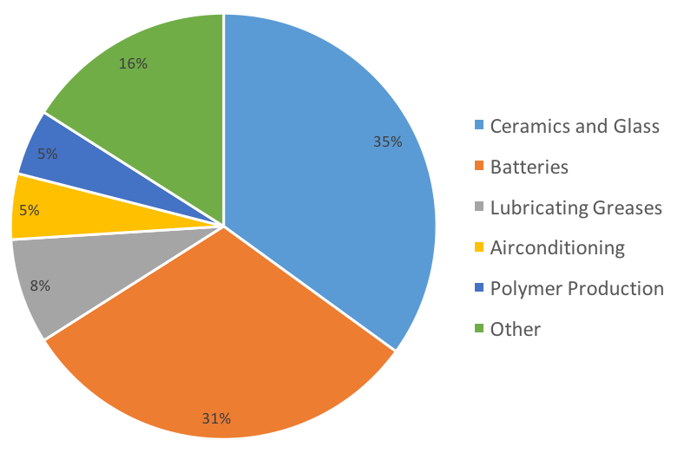
Due to its contractual nature, lithium prices tend to fluctuate considerable by geography and grade. Battery-grade lithium carbonate, which sold for about $5,800 a tonne in 2011, has become more expensive over the past few years even though the price of batteries has fallen. The metal hit $6,880 at the end of 2013 and is now trading around $8,000. This performance is very rare when put against other metals and looks incredible when matched up against nickel or aluminum. Stories of lithium reaching $18,000 a tonne are purely centered around the Chinese market, where there is unique market. Lithium prices have doubled in the last two quarters largely due to concerns about inventory shortages in China as domestic companies are no longer getting a steady supply from Australia. Chinese battery manufacturers who are intent on dominating the market are desperate for the material and will pay a premium price to keep their industry growing. Jon Hykawy, President of Stormcrow Capital Ltd, who are tracking the lithium market says that lithium demand could effectively double to 400,000 tonnes a year in a decade.

Supply

The world’s top lithium-producing countries, as per 2015 data reported by the US Geological Survey (USGS) are as follows:

• Australia – 13,400MT: The most well-known lithium project in the world is the Greenbushes lithium project, which is owned and operated by Talison Lithium, a subsidiary jointly owned by China’s Tianqi Group and US based Albemarle. Greenbushes is the world’s largest known single lithium reserve, and has been operational for over 25 years. The reason for its success is its geographical location allowing easy access for Asian electronics companies, which are the world’s top lithium consumers. The space isn’t just controlled by the major groups, junior mining companies such as Pilbara Minerals are also advancing lithium projects, while Galaxy Resources is working to restart production at its Mt Cattlin spodumene project in Western Australia. Australia holds the third largest amount of lithium resources worldwide with roughly 1.5 million MT of the soft metal. It’s worth noting that much of Australia’s mined production is exported to China in the form of hard-rock spodumene, where it is then further processed into end products such as lithium carbonate and lithium hydroxide.

• Chile – 12,900MT: Overall, Chilean mines feature the largest confirmed lithium reserves in the world, with over 7,500,000 MT of lithium. By that estimate, the country hosts roughly five times more lithium than Australia, previously stated. In particular, the Atacama salt flat is the most significant source of Chile’s massive lithium production. BBC News reported that one project alone encompasses approximately 20 percent of the world’s total lithium. While Australia extracts lithium from traditional hard-rock mines, Chile’s lithium is found in brines below the surface of salt flats. These brines are collected and treated in order to separate the lithium from wastewater. The region is extremely arid, making it conducive to lithium extraction via evaporation ponds. Extracting through brine is the most popular form of lithium production, whether that be from salt flats or from geothermal brine, the by-product of geothermal production.

• Argentina – 3,800MT: Argentina is very similar to Chile in it geological conditions and vast salt flats. Bolivia, Argentina and Chile comprise the “lithium triangle,” and the most important salt flat in Argentina is the Salar del Hombre Muerto. Unlike Chile and Australia with their fully developed projects in place, Argentina is still growing in the Lithium game. The biggest player at the moment is Orocobre, which is planning to expand its production at its Olaroz facility in the country. A good sign for the countries future is the recent election of Mauricio Macri as President of Argentina whom is already bringing a political shift that is expected to be positive for the mining industry in the country. He is extremely pro- business and wants Argentina to exploit the vast amount of resources it holds.

• China – 2,200MT: Although some way down the list of lithium producers, the country’s massive electronics manufacturing industry means that China is the world’s largest consumer of lithium. Unfortunately, as it stands the lithium extraction market in China has yet to ramp up its internal production to meet its high domestic demand. Currently, the majority of Chinese lithium comes from the Chang Tang plain in Western Tibet, and the country is rushing to develop its lithium production capacity, with plenty of room to grow. The US Geological Survey pegs the country’s lithium reserves at around 3,500,000 tons. China sources much of its raw lithium supply from Australia via Chinese owned companies Sichuan Tianqi Lithium and Jiangxi Ganfeng Lithium which are two of the top producers of lithium products worldwide.

• Zimbabwe – 900MT: Privately held Bikita Minerals controls nearly all of the country’s lithium mining, and announced expansion plans in the summer of 2014. Since then there has been a lot of investment into the country s lithium resources are meant to be growing with large hard rock mineralization capabilities.

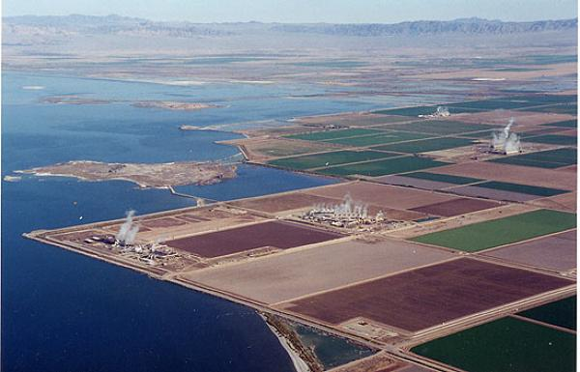
• United States – Undisclosed (830MT in 2013): The US is a fairly untapped resource in the lithium extraction industry. It is home to a single lithium mine controlled by Rockwood Holdings, which was acquired by Albemarle in 2015. Although it is referred to as a mine, this is a brine operation in Nevada where there are untouched reserves. The US Geological Survey does not release national production numbers to protect the company’s trade secrets, however, it is thought that there is a nascent opportunity for growth in the US lithium market that has been spurred on by the Tesla Gigafactory in Nevada. The area has now become a hot spot for lithium juniors, with companies such as Dajin Resources and Pure Energy Minerals conducting exploration work on brines in the Nevada. The Salton Sea region located in the Imperial Valley of California is also seen as having huge potential. In mid 2014 Tesla’s Elon Musk tried to purchase Simbol Materials, a small scale brine extractor working with the geothermal energy plants, for $325 million dollars. The transaction fell through as the company went into liquidation for a variety of reasons unrelated to the lithium demand or lack of technology. There is now an empty void in the Salton Sea area to exploit these vast untapped lithium reserves.

A cluster of 12 geothermal power plants owned by CalEnergy and Energy Source are already in production in the Imperial Valley which is regarded as one of the most prolific areas in the US for geothermal production. Hot concentrated saline solution is pumped via a network of deep wells drilled into the underground reservoir to power electrical generators. Electricity thus generated is sold to the local grid powering over 150,000 homes and businesses.

Growth in the geothermal sector in this region looks set to increase over the next decade in response to recent proposals to increase California’s renewable energy to over 50%. There are applications in place for several new large (Controlled Thermal Resources, an Australian company has plans for a 250 megawatt plant) geothermal permits over ‘geothermal hotspots’ now becoming apparent as the Salton Sea recedes.

This geothermal brine from these geothermal plants contains significant amounts of dissolved metals including Lithium and is in effect produced as a by-product of this geothermal electricity generation. The recent surge in demand and prices for lithium products has refocused attention on these vast, but so far undeveloped lithium resources contained in this geothermal brine.

• Portugal -300MT: The majority of the country’s known lithium stores are centrally located in the Goncalo aplite-pegmatite field. There are other areas of the country that may contain large amounts of lithium, but further exploration will be required to determine whether these deposits could be developed economically. Despite the growing Lithium market, smaller countries with unexplored lithium reserves are getting less attention as there is plenty of known reserves that are being acted on around the world.

• Brazil – 160MT: The country has deposits of the mineral in a few northern areas, including Minas Gerais and Ceara, but Brazil’s known lithium reserves remain relatively small.

Automotive Demand

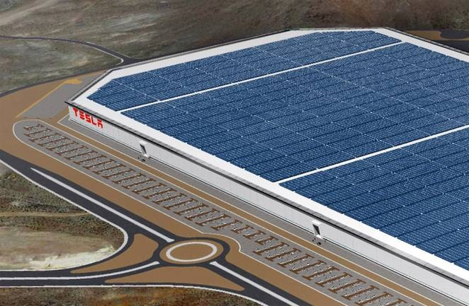
Tesla has driven the thrust in current automotive transition to electric vehicles (EVs). As the company’s mission statement outlines, it hopes “to accelerate the advent of sustainable transport by bringing compelling mass market electric cars to market as soon as possible.”
However, since 2014, when Tesla first announced the Gigafactory with Panasonic, other manufacturers have begun to take notice and take action. Volkswagen AG announced last week that it was considering LG Chem Ltd. or Panasonic Corp. as partners for several US$2-billion factories, according to Bloomberg, with confirmation expected later in the year.

Previous announcements of billion-dollar investments in battery factories by Volkswagen were largely brushed off by investors as deflections from their ‘Dieselgate’ scandal. But with LG and Panasonic in the picture, concrete plans appear to be crystalizing. Combined with Daimler putting US$550 million into tripling its battery production capacity in Germany, Nissan’s planned investments in the UK for its third generation Leaf, and GM’s joint venture with LG Chem to produce batteries in Holland, Michigan, for its Volt and Bolt, it is clear that auto manufactures are beginning to shift to electric—and in a very big way.

Given this new investment, plug-in electric vehicle (PEV) sales are expected to experience 62% year on year growth in 2016, 60% in 2017, and likely 100% in 2018. This translates into over 600,000 in PEV sales expected in 2018, creating a new level of demand for which the market will need two new “substantial” lithium mines in operation to even begin to satiate the market. In terms of how much Lithium we need, Lithium-ion electric vehicles can be designed with a large variation of battery capacities. However, if you take the median Nissan Leaf electric car, which has a slightly smaller battery than the Teslas, you find that every 10 kWh requires 1 kg of lithium, so it takes at least 2.4 kg of lithium to make this battery.

Energy Storage

The real game changer for the lithium industry may be electrical grid storage. Grid storage is designed on a variety of scales, each with a different price point. Already price-competitive with diesel fuel for stand-alone renewables and remote locations, home storage applications and grid frequency modulation applications these devices are now making major inroads in the grid storage market.

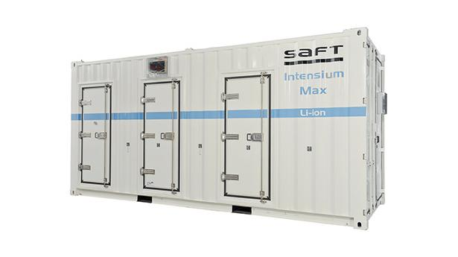
In some locations, grid-scale peaking applications and frequency control have already been implemented, often in old coal power plants, re-using the building and grid connections.

Grid-scale storage battery demand can easily eclipse the need for automotive batteries. Battery experts note that although different battery chemistries exist, the energy density of lithium is far superior to other chemistries.

No new battery chemistry will supplant lithium ion battery cathodes for decades, and lithium cathodes are the centerpiece of several leading chemistries which are already available.
 | 2014 Sales  (M Units) | Li Content per unit  (LCE Basis) | 2014 Total Li Content  (LCE Basis) | Projected CAGR  (2014-2024)
Smartphone | 1,200 | 5-7 grams | 8,400 MT | 8-10%
Tablet | 260 | 20-30 grams | 7,800 MT
Notebook | 170 | 35-45 grams | 7,650 MT
Power Tools | 65 | 40-60 grams | 3,900 MT | >15%
HEV | 1.8 | 5 kilograms | 9,000 MT | 20-30%
PHEV & BEV | 0.3 | 40-80 kilograms | 18,000 MT
Stationary | (650 MWh installed) | 1.5 MT | 1,000 MT | >30%

The Future

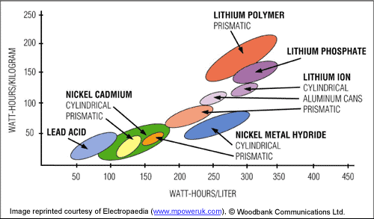
The global push for cleantech solutions in transportation to satisfy the growing demand has led to the lithium ion battery market being extremely strong. However, technology is nothing without searching into the future for the next generation batteries that will improve on Lithium ion batteries. Lux Research has found that, although incremental improvements may extend the dominance of lithium ion batteries over the next ten years, a new generation of batteries will eventually displace their monopoly on the EV market. The research group anticipates that this new market of “next-generation” battery technologies will be worth a staggering US $10 billion by 2030.

Investment in the lithium industry look ready to accelerate in the next few years as the applications for batteries gains more momentum. It is thought that the biggest growth in batteries will actually come from gradually evolving Li-ion batteries, through incremental innovations such as higher-voltage cathodes and electrolytes, as well as the use of “higher-capacity active” materials like silicon-containing composites. The real next-generation battery technology will not be until after 2030 at which point it is forecast that solid-state batteries will have roughly a $3 billion stake in transportation and $2 billion in electronics. The other next generation alternative that is being discussed is lithium-sulfur which is though will capture market share too, though its growth will be slower.

What do these new technologies mean for a Lithium extracting business? Lithium-sulfur is thought to have a higher energy density than lithium ion batteries as well as being cheaper to produce due to the sulfur content. However, this technology is very much in its infancy and the high proportion of lithium needed for these batteries will continue to drive the market for lithium. There are many kinds of solid-state batteries that are being developed at the moment, all using the concept of removing the liquid electrolyte and replacing it with a solid electrolyte. This prevents fires, increases storage capacity and reduces degradation meaning the batteries will last longer. It is a technology still in its development stage but lithium leads the pack for the base material of the battery. Therefore, it remains our view that the future for lithium looks bright with its application to most different types of battery formats.

Looking even further into the future developments in technology even show signs of “lithium-air batteries” making their way into the market, but there are still serious challenges that need to be resolved for this technology to work.

Summary

This report clearly shows the impressive characteristics of lithium as a metal and its ability to fuel the battery and energy storage industries for the foreseeable future. There does not appear to be a better alternative for its energy storage properties. Lithium is far superior than any other battery chemistries in both energy density and weight and it therefore will continue to dominate the battery industry for several decades.

The lithium market is going to represent a great potential opportunity for investors over the next few years as supply becomes more challenging and demand looks set to explode. The surge in automotive and storage demand are set to put a strain on existing suppliers opening up a market for new entrants. Political pressure will play a significant role as governments across the world push for cleantech solutions and renewable sustainability in which lithium will continue to be heavily required. Demand from China, in particular is very underestimated as the Chinese battery manufacturers continue to be the largest lithium consumers in the world.

Not all lithium companies will be able to take advantage of this opportunity. Whilst lithium is a global market, certain areas with substantial untapped reserves of lithium that have the capability to become major world producers will emerge. The Salton Sea geothermal region is one such example of a perfectly located source of potentially unlimited supply within easy reach of major ports on the West Coast of the US destined for world markets and indeed to potentially fuel the Tesla Gigafactory in Nevada which will be a substantial domestic consumer of lithium. In addition, California is becoming a hub for energy storage innovation with several energy storage startups breaking through. You could easily see a new major producer in the lithium industry being located in the US Southwest due to its existing geothermal production, the quality of the lithium produced and its strategic location.

